RALLY AT THE FREEDOM WALL
CITIZENS UNITED AGAINST THE ATLANTIC COAST PIPELINE

SATURDAY, JANUARY 10, NOON – 1 PM
FREEDOM WALL, DOWNTOWN MALL
Charlottesville, Virginia

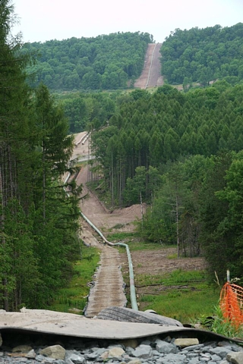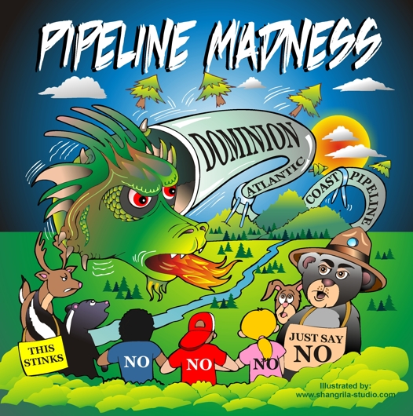

* Come and voice your opposition to Dominion Resource’s proposed 42” high pressure gas pipeline
* Learn where to write to voice your objections.
* Petitions to sign, guest speakers, music.
* Signs, bumper stickers, t-shirts will be available

Sponsored by the Piedmont Group and Shenandoah Valley Groups, Sierra Club, Charlottesville Peace and Justice Center, 350.org, Friends of Nelson,

