Excerpts from Comments to the SCC 8/17/18

Gas Supply

All DEV Power Plants Are Adequately Served by Existing Pipelines

All major gas-fired power plants operated by Dominion Energy Virginia are currently supplied using long-term transportation agreements with existing pipelines. DEV has canceled plans for any future combined cycle units and has announced that it has no plans to build more. Even if those plans were to change, the approved expansions to existing pipelines serving Virginia provide greater capacity than would the Atlantic Coast Pipeline (ACP).

The combustion turbines proposed in the 2018 IRP would likely be located near the largest load centers. The ACP corridor is not near any of DEV’s largest load centers, except for the terminus of a moderate volume lateral pipeline near southeast Virginia. Any projected peaking units could be served by the ample capacity in existing pipelines.

The justification for the Atlantic Coast Pipeline was that nearly 80% of its capacity would be used to supply new power plants in Virginia and North Carolina. Both proposed gas-fired plants in Virginia have been canceled and four of the six plants originally proposed in North Carolina have been canceled. The remaining plants in North Carolina are likely to succumb to the lack of load growth and the lower costs of other methods of generation that led to the cancellation of the other gas-fired units. In any case, expansion in the capacity of the existing pipeline system in North Carolina provides more capacity than does the ACP to meet any future needs.

Transco, the nation’s largest pipeline system that serves much of the Atlantic Seaboard including Virginia and the Carolinas, has intervened in the South Carolina Public Service Commission proceeding regarding Dominion Energy’s proposed purchase of SCANA. Transco’s filings say that Dominion’s Atlantic Coast Pipeline is unnecessary and duplicates the Transco infrastructure that has provided reliable service to the region for decades.

The Federal Energy Regulatory Commission (FERC) did not consider any information regarding possible increased demand for natural gas, or the need for more gas-fired power plants, or the ability of existing pipelines to serve any future need. There was no independent evaluation of the factors typically considered in a CPCN process and no evidentiary hearing. FERC only considered the existence of long-term transportation agreements signed by companies controlled by the owners of the pipeline. Commissioner LaFleur voted against issuing a certificate for the Atlantic Coast Pipeline, saying it was not in the public interest.

Those long-term transportation agreement contracts remain. They obligate the utilities controlled by the pipeline owners to pay for a pipeline that they do not need. Those utilities, including DEV, expect to be able to pass those costs on to their ratepayers.

Expansion of Existing Pipelines Serving Virginia

Columbia Gas Pipeline – 1.3 Bcf/d
An expansion of the Columbia Gas Pipeline, the WB XPress project, will add 1.3 billion cubic feet per day (Bcf/d) of added capacity to the regional system. Adding this new capacity requires less than 3 miles of new construction, 26 miles of replacement pipeline, two new compressor stations, and other modifications.
The supply area for this pipeline, in addition to its Gulf Coast connection, is in the same western Pennsylvania and West Virginia region that the Atlantic Coast Pipeline and the Mountain Valley Pipeline intend to tap. The Columbia Gas pipeline has been in service for decades. Requiring just a few miles of new construction and additional compressor facilities, it will provide nearly the capacity of the ACP.
The customers for this new capacity have not been identified for competitive reasons. However, it is likely that not all of the added capacity will be available to Virginia. Some will probably be allocated to portions of the Columbia Gas system farther north. In the application for the ACP, Dominion reported an agreement with Columbia Gas for it to move its 0.300 Bcf/d allocation into Virginia from a connection with the ACP in West Virginia. This confirms that Columbia Gas has at least this much capacity to move additional supplies of gas into Virginia.
With the new gas-fired power plants canceled and no plans for more, this is twice what the remaining requirement for service to Virginia is from the ACP. Virginia Natural Gas has reserved 0.155 Bcf/d, just 12% of the capacity that Columbia Gas is adding to its system.
The WB XPress project also includes a connection to the Transco pipeline corridor running through Virginia. This provides access to the abundant supplies of gas in the Transco system that can be transferred to the Columbia Gas system that covers much of Virginia. This system already feeds many of the gas distribution systems that supply residents and businesses throughout Virginia.
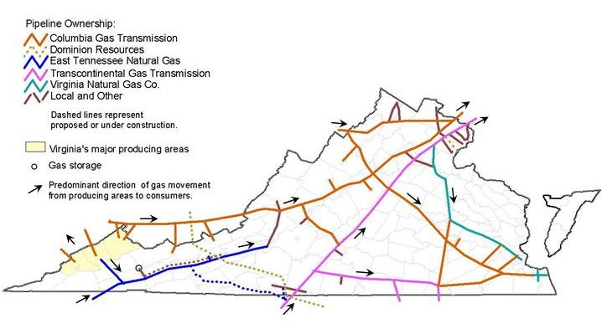
Transco
The over 10,000 mile Transcontinental Pipeline system, initially developed in the 1950’s, runs 1,800 miles from the Gulf Coast production zones and along the eastern seaboard to metropolitan demand centers in the northeast.
About 30 percent of all U.S. natural gas has some association with the Transco system. Over one-third of the production in the Appalachian Basin is gathered by Transco pipelines. The Transcontinental system grew from a capacity of 10.8 Bcf/d in 2014, to 17.7 Bcf/d in 2017, with a projected capacity of over 22 Bcf/d by 2025. By adding over 11 Bcf/d in capacity in about a decade, the Transco system provides an abundant source of natural gas supply. Transco serves Virginia, nearly 100% of North Carolina’s gas requirements, and most of South Carolina’s.
Development of shale gas production in the Appalachian Basin over the past 10 years has significantly altered the movement of natural gas from its traditional pattern of south to north. As new takeaway pipelines are built to bring the production of the Appalachian Basin into the national gas transmission system, much of the demand in the northeast can be served directly from the Appalachian Basin. This frees up the Transco system to move gas from the Appalachian Basin to markets in the Southeast and as far south as the Gulf Coast.
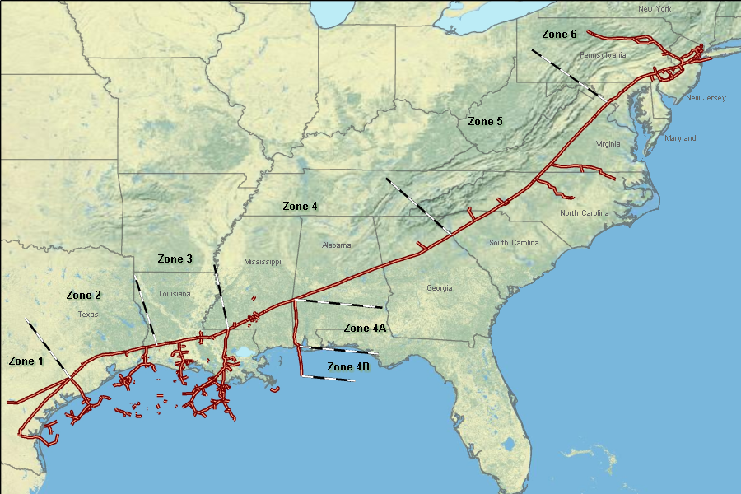

Transco - Virginia Southside Expansion Projects I & II (0.520 Bcf/d)
This project involved one of the early reversals of flow on the Transco system. Project I provided 0.250 Bcf/d of gas to fuel Dominion’s Brunswick power plant scheduled for operation in 2016. An additional 0.020 Bdf/d was piped over the border to supply Piedmont Natural Gas in North Carolina. At the end of 2017, the pipeline was extended by four miles to connect with the Greensville power plant that should begin operation by the end of 2018 or early 2019. A total of 0.250 Bcf/d will be provided to the Greensville plant using additional compression.
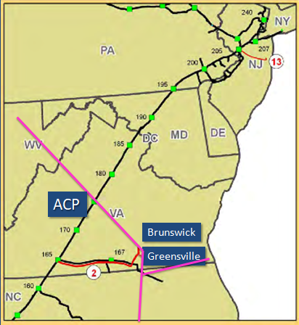
Transco Southside Expansion Project

In its application for the Atlantic Coast Pipeline, Dominion argued that the new pipeline was essential to serve these power plants. However, Dominion did not reserve enough capacity on the ACP to serve both of these plants operating at full power, let alone serve these two plants plus the new plants it said it needed the Atlantic pipeline to serve. Regardless of the rationale, the transportation cost on the ACP is over three times the cost of transporting gas on the Transco pipeline.
Transco Atlantic
Gas required: Gas available:
Brunswick 250,000 Dth/d
Greensville 250,000 Dth/d
500,000 Dth/d 500,000 Dth/d 300,000 Dth/d

Date required: Date provided:
Brunswick Fall 2015 Fall 2015 ?
Greensville Late 2017 Late 2017 ?

Rate of return 15.34% 15.00%

Transportation charge $0.53 /Dth $1.88 /Dth

Transco – Atlantic Sunrise (1.7 Bcf/d)

The Atlantic Sunrise project was designed to support the increasing flow of gas from north to south and share the abundant supplies of gas from the Appalachian Basin with markets in the Mid-Atlantic and Southeast regions. The capacity was allocated among the shippers, in exchange for a 15-year firm transportation agreement, as follows:

Shipper Reservation (Dth/d) Type of Organization

Andarko Energy Services 44,048 Marketing company

Cabot 850,000 Gas producer

Chief Oil & Gas 420,000 Gas producer

Inflection Energy 26,429 Gas producer

MMGS 22,024 Marketing company

Seneca Resources 189,405 Gas producer

Southern Company Services 60,000 Marketing agent

Southwestern Energy 44,048 Marketing company

WGL Midstream 44,048 Marketing company

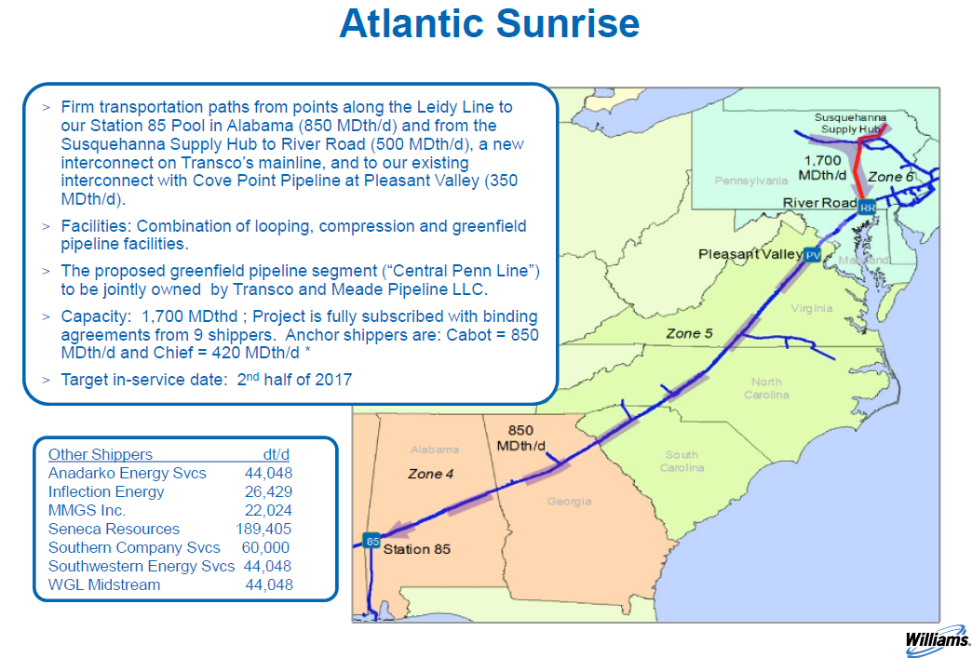

This project is fully subscribed, meaning that all of the capacity of the pipeline is under contract to various shippers. If those signing the contracts are utility companies or Local Distribution Companies, it can signify that there is a true a true market demand for the gas. However, pipeline owners often have their utility subsidiaries sign contracts to give the appearance of a demand in order to gain approval to build a new pipeline.

All of the shippers that have subscribed to the Atlantic Sunrise pipeline are either gas producers or marketing companies. There are no end-users of the gas. But the presence of contracts was enough for FERC to approve the project.

Dominion signed a supply contract with Cabot to provide 350,000 Dth/d to Cove Point for liquefaction at the Cove Point LNG export facility. Cabot still had 500,000 Dth/d for which they were seeking buyers. The other shippers on the pipeline had 850,000 Dth/d of available capacity and were also searching for customers.

When the Atlantic Coast Pipeline submitted its application to FERC it claimed that the Atlantic Sunrise was fully subscribed. This makes it seem that no gas was available from the Atlantic Sunrise Pipeline to supply Virginia and North Carolina. Saying that the Sunrise project was fully subscribed was accurate, but implying that no gas was available to supply the potential customers of the ACP was not.

The amount of capacity available on the Atlantic Sunrise project was nearly equal to the actual amount eventually subscribed by the Atlantic Coast Pipeline. The utility customers of the subsidiaries of the owners of the ACP would have saved hundreds of millions per year. The cost of transporting gas using the Atlantic Sunrise Pipeline to Transco Zone 5 (Virginia, North and South Carolina) is about 40% of the cost of transportation using the Atlantic Coast Pipeline.

Saving their customers money does not appear to be the primary motivation of the utility holding company owners of the ACP; owning a pipeline yields billions in profits. The utility customers assume the risk of the project by paying the full amount of the firm transportation agreements, whether the reserved capacity is used or not.

Southeastern Trail Expansion Project

The Southeastern Trail Expansion is a 0.296 Bcf/d expansion of the Transco pipeline system intended to provide additional pipeline capacity to serve markets in the Mid-Atlantic and Southeastern states by November 2020. The project will provide additional capacity for the 2020/2021 heating season to utility and local distribution companies located in Virginia, North Carolina, South Carolina and Georgia; including Public Service Company of North Carolina, South Carolina Electric & Gas, and Virginia Natural Gas.
Existing Pipelines are Adequate to Serve Even a High Gas Use Scenario

Synapse Energy Economics compared market demand with the ability of existing pipelines to serve it. This was precisely the type of evaluation that FERC should have conducted, but did not. The Synapse report concluded that the upgrades and reversal of flow in existing pipelines could provide a supply of natural gas to the region that was significantly in excess of even the highest-demand scenario. The study revealed that no new pipelines are needed to assure an ample supply of natural gas to Virginia and the Carolinas. No equivalent information has been provided by the pipeline developers or by FERC to show that the situation is any different than what Synapse has concluded.

Synapse examined forecasts for peak natural gas usage in the Southeast region from Local Distribution Companies (LDC’s) and the demand increase attributed to the new gas-fired power plants proposed through 2030. This comparison was based on the estimate of required new power plants projected at the time the pipeline application for the Atlantic Coast Pipeline was submitted in 2014. For the first time, an analysis of the growth in natural gas demand was compared to the capacity of existing pipelines in the region to determine if existing pipelines could adequately supply the increase in demand from the new power plants and traditional uses of natural gas.

Researchers assessed the “peak hour” demand in the expected gas usage scenario and also evaluated a “high gas use” scenario that assumed less-than-expected use of renewable energy, and greater than anticipated coal-fired power plant retirements. Expected capacity additions from the reversal of flow in the Transco corridor bringing large supplies of natural gas from the Appalachian Basin to Virginia and North and South Carolina and extra capacity that would remain in the region from the 1.3 Bcf/d expansion of the Columbia Gas Pipeline were considered as part of the regional capacity.

Choosing to build an unnecessary new pipeline when existing pipelines can provide the same or greater capacity adversely affects the interests of those existing pipelines, costs electric utility ratepayers hundreds of millions more per year, severely disrupts sensitive environmental areas, and infringes on personal property rights without a valid reason.

As shown, approved expansions of existing pipelines will provide more capacity than would be provided by the Atlantic Coast Pipeline. It makes sense to use what we have before building something new. The following section describes how expensive the unnecessary capacity will be for ratepayers.

DEV Ratepayers Are Expected to Pay $4 Billion for an Unnecessary Pipeline

Just as it failed to independently evaluate the need for the Atlantic Coast Pipeline, FERC failed to evaluate the “public convenience” of the project, or its overall benefit to customers and the general public. Instead it relied on a report commissioned by Dominion that said the ACP would provide energy cost savings that would result in a benefit of $377 million per year to Virginia and North Carolina. The savings derives from two basic assumptions. First, that gas from the ACP supply zone in West Virginia would have a price advantage compared to the national price (determined at Henry Hub in Louisiana) that would “occur early in the life of the project and grow steadily over time.” And second, that this average savings of $1.61 /Dth would “far exceed[ing] the proposed transportation rate on the pipeline.”

It is not clear why developers of the Atlantic Coast Pipeline chose to compare the price of Appalachian Basin gas with the price at Henry Hub since the production zones that would supply gas for future uses in Virginia and North Carolina are in the Appalachian Basin. However, even with the existing price advantage of Appalachian Basin gas compared to Henry Hub, that price advantage could well be short lived.

It is a common occurrence in the gas industry that once sufficient takeaway pipelines exist to deliver the full output of a production zone to market, gas prices from that zone will equalize with other markets. Twenty-five new pipelines are scheduled to be added in the Appalachian Basin by the end of next year. According to Bloomberg, new projects would increase the takeaway capacity in the Appalachian Basin by 71 percent, far outstripping the production capability of the region for at least the next five years. This much surplus pipeline capacity would serve to equalize prices for quite some time. It is also possible that the low-cost associated gas from oil production in the Permian Basin in Texas could reduce price differentials at Henry Hub compared to other trading hubs. Whatever the cause, it is likely that an average gas price differential as large as the $1.61 /Dth assumed in the ICF report would fail to materialize over the first 20 years of operation of the ACP.

However, if we assume the expected $1.61 /Dth price advantage projected by ICF does occur, does that make the ACP a good deal for DEV ratepayers? No, it doesn’t. ICF assumed that the optimistic $1.61 /Dth savings at its supply zone would far exceed the cost of transporting gas using the ACP. But ICF failed to account for the actual cost of $1.88 /Dth for transporting gas using the ACP (based on rates published with FERC, including the supply header). In reality, there is no savings provided by the ACP to run through a magic multiplier to create a $377 million per year savings. This figure is a fiction used to convince the public, politicians, and FERC that the project was a good idea.

Dominion provided information to the State Corporation Commission (SCC) that shows the cost of transporting gas to its power plants using long-term firm transportation contracts with existing pipelines is up to eight times cheaper than the cost of transporting gas using the Atlantic Coast Pipeline. All major gas-fired power plants that DEV intends to use over the next 15 years have low-cost long-term firm transportation agreements with existing pipelines. There is no benefit to DEV ratepayers provided by the Atlantic Coast Pipeline.

It has been shown that the low-cost Columbia Gas Pipeline that serves Virginia has the capacity to transport DEV’s full allotment from the ACP (300,000 Dth/d) from the West Virginia production zone into Virginia at a fraction of the cost of the ACP. Transporting gas using the ACP will add a 60-75% premium to the current price of gas making gas delivered by the Atlantic pipeline much more expensive than other alternatives. The $1.88 /Dth should be added to the commodity cost estimates for natural gas provided in the 2018 IRP to see if the ACP has any benefit to DEV customers. It is much cheaper to use pipelines that have been mostly paid for by previous customers than it is to use a new pipeline.
It is important to note that gas is purchased separately by the end-user. Pipelines just provide the delivery service. A pipeline is only cost-effective if it provides access to sources of gas that, after the addition of the pipeline transportation fee, delivered gas arrives at its final destination priced cheaper than if it was obtained using other pipelines. The Atlantic Coast Pipeline is a very expensive delivery service. It cannot compete with the ample capacity in the lower cost pipelines that supply DEV’s service territory.

Based on the tariff published with FERC, transportation of gas on the Atlantic Coast Pipeline and its supply header would cost $1.88 /Dth. A slightly lower rate could have been negotiated with the pipeline, but that information is confidential. However, the ACP has announced that the project will cost $1.5 billion more than expected. After the first three years of operation, the ACP can report the actual costs of construction and early operation to FERC to support a rate increase. It could turn out that the published rate is actually lower than what might apply during the operation of the pipeline.

The amount of capacity reserved by the long-term transportation agreement times the published transportation rate yields a commitment by DEV to pay the Atlantic Coast Pipeline over $4 billion over the next 20 years. The transportation rate could be adjusted up or down during this period and this represents a stream of payments, not a net present value.

Even though all current and planned facilities can operate at the lowest cost without using the Atlantic Coast Pipeline, Dominion has told the SCC that it intends for its electric ratepayers to pay the $4 billion in costs for its 20-year firm transportation agreement with the Atlantic Coast Pipeline. This payment is due in full regardless of how much of the reserved capacity is actually used.
State law limits the SCC’s ability to pass on costs to utility customers that are the lower of actual costs or market prices. This would restrict DEV’s ability to recover the cost of its agreement with the ACP. Since there will be no new power plants that require additional gas service, and gas delivery using existing pipelines to current power plants is far cheaper than using the ACP, there is no justification that any of the $4 billion transportation contract with the Atlantic Coast Pipeline should be borne by Dominion’s electricity customers. Approving the pass-through of the new pipeline costs would add $200 million per year in costs to DEV ratepayers without any offsetting benefit.
Gas-fired power plants just a few years old have been forced to close in other parts of the country because of the price pressure from lower cost alternatives. “Natural gas investments today could become stranded assets in 10 years” reports an article in Utility Dive. According to research, $112 billion in planned natural gas generation investments and $32 billion in pipeline commitments are “already at risk of becoming stranded assets.” The agreement with the ACP signed by DEV’s subsidiary could ultimately transfer the costs and risks of this speculative project onto its ratepayers.
We need to be certain that we have an adequate gas supply to operate our energy system. But we should be cautious about building expensive and unnecessary pipeline projects in Virginia that could saddle our citizens with billions of dollars in added energy costs with no benefit in return.
The Commission missed an opportunity to address the lack of need for the ACP to serve DEV customers in an Affiliates Act case. It is understandable that the SCC wanted to avoid dealing with a politically sensitive issue. Even the Virginia Supreme Court avoided dealing with the facts of the matter. However, if the pipeline is built despite the fact that it isn’t needed for us to have an adequate supply of gas and the fact that is far more expensive than available alternatives, state law requires the SCC to deny recovery of the cost of the contract with the ACP.
There is no unmet need for the ACP to fulfill. All facilities are under long-term capacity contracts that are up to eight times cheaper than the cost of using the ACP. In last year’s IRP hearing DEV argued that the ACP would be considered a “portfolio asset.” It would be hard to argue that a $4 billion expense that serves no useful purpose is an “asset.” The regulator exists to protect the interests of the ratepayers. This is definitely an instance where such protection is required.
The utility might argue that the pipeline has received a certificate of public convenience and necessity from FERC and therefore should qualify for cost recovery. However, there is nothing in the FERC record that would support the need or cost advantage to DEV customers, because no such evaluation was undertaken by FERC or supported by information supplied by the applicant.
The SCC should join the challenge to the FERC certificate in federal court. Avoiding building an unnecessary pipeline that might not qualify for much of its expected cost recovery (North Carolina utilities are in the same situation as DEV) would reduce the harm to the utility holding companies that own the pipeline. We need financially strong utilities to create a modern grid for Virginia. If the 2018 IRP is evidence of the quality of their plan, we have a long way to go. But proper measures are even less likely to be taken if the parent company is hobbled by an ill-conceived pipeline project.

Petition for Rehearing and/or Reconsideration, Transcontinental Gas Pipe Line, LLC, Public Service Commission of South Carolina, Docket 2017-370-E, July 16, 2018
WMB - Williams Companies Inc and Williams Partners LP Analyst Day, THOMSON REUTERS STREETEVENTS, May 13, 2015
Application for Certificate of Public Convenience and Necessity, Virginia Southside Expansion Project II, Filed March 23, 2015, Exhibit P
Amendment to Application for a Certificate of Public Convenience and Necessity and Blanket Certificates, Atlantic Coast Pipeline, Docket No. CP15-554-001, Volume I Public, March 11, 2016, Exhibit P (includes tariff for supply header)
Are the Atlantic Coast Pipeline and the Mountain Valley Pipeline Necessary?, Synapse Energy Economics, Inc., September 12, 2016, https://www.southernenvironment.org/uploads/words_docs/2016_09_12_Synapse_Report_-_Are_the_ACP_and_MVP_Necessary__FINAL.PDF
The Economic Impacts of the Atlantic Coast Pipeline, ICF International, February 9, 2015
Ibid., p 9
“Natural gas pipeline projects lead to smaller price discounts in Appalachian region”, U.S. Energy Information Administration, Today in Energy, August 16, 2017
Anastacia Dialynas, “U.S. Gas Insight: Pipelines to boost App Basin Takeaway. Forecasted build-out of App Basin gas Pipelines, 2017-18,” Bloomberg New Energy Finance, March 2, 2017
Application of Virginia Electric and Power Company to revise its fuel factor, State Corporation Commission, May 2017, Case No. PUR-2017-00058
Amendment to Application for a Certificate of Public Convenience and Necessity and Blanket Certificates, Atlantic Coast Pipeline, Docket No. CP15-554-001, Volume I Public, March 11, 2016, Exhibit P
Cost of ACP skyrockets, John Downey, Charlotte Business Journal
California Merchant Generator, Lamenting Market Forces, Files for Bankruptcy, Power Magazine, Dec. 8, 2016
End of the ‘gas rush?’ Renewables, storage reaching cost parity, report finds, Herman K. Trabish, Utility Dive, June 11, 2018, https://www.utilitydive.com/news/end-of-the-gas-rush-renewables-storage-reaching-cost-parity-report-fin/524840/

