To Understand Pipeline Economics, Follow the Money
September 5, 2017 by TomH
By Thomas Hadwin
I have worked for electric and gas utilities in other states, so I am interested in seeing a modern energy system developed in Virginia. I prefer to find solutions where everyone wins, but Virginia is currently split between those who want to protect our land and waters and those who want the lower cost energy and jobs they think pipelines will bring. We can find ways where all interests are served, but we will have to reshape the plans that have been proposed.
The promised economic benefits are what have motivated many political and business leaders to support the Atlantic Coast Pipeline (ACP). Let’s set aside the environmental issues and focus on the economics. In dealing with contentious issues, it’s often hard to find agreement on the “facts.” We can avoid disagreement by using information that the pipeline owners (Dominion Energy, Duke Energy, and Southern Company, the parent company of Virginia Natural Gas) have filed with the Federal Energy Regulatory Commission (FERC).
To show FERC that a new pipeline would be needed, the pipeline owners had their utility subsidiaries in Virginia and North Carolina sign 20-year firm transportation agreements with the Atlantic Coast Pipeline. FERC’s own guidelines say that this is not enough to prove true market need for a new pipeline, especially if the companies signing those contracts are owned by the pipeline developers. U.S. Department of Energy studies and reports from independent consultants show that existing pipelines can provide all of the gas we need in Virginia and North Carolina. Unfortunately, FERC has not requested any substantive data to prove the need for a new pipeline. Signed contracts are all that have been used to approve pipelines for the past several decades and it appears that this substandard practice will continue.
Dominion claims that the cost savings provided by the ACP are enough to prove it is necessary. Will the ACP actually save ratepayers money in Virginia and North Carolina? Enough to spur new job creation, as has been advertised? The truth is revealed by examining who pays for the $5 billion ACP, and how much it costs compared to other options.
Data filed with FERC show the ACP will cost customers more than existing pipelines
Pipelines charge a fee to transport natural gas. The gas itself is purchased separately. Traditionally, large users of natural gas, such as utilities, have signed long-term contracts to reserve capacity on a particular pipeline. These contracts must be paid in full, whether or not all of the capacity is used. Having the capacity reserved assures that natural gas can be delivered when it is needed and reduces the price volatility compared to paying for pipeline transportation only as it is needed.
Capacity reservations can be a good idea, but not when the cost of the long-term contract is far higher than other alternatives. Based on the fee and the capacity reservation filed with FERC, Dominion’s utility customers could be obligated to pay over $4 billion during the next 20 years to the ACP for the long-term transportation agreement.
Existing pipelines, currently serving Virginia, can transport the same or greater amount of gas as the ACP for a much lower cost, because existing pipelines have been mostly paid for by previous customers. Using gas prices from May of this year, which show a price advantage at the Dominion South zone (the source of supply used by the ACP), the total price of gas delivered by the ACP to Dominion’s Brunswick plant would be 28% more expensive than gas delivered by the connection to the Transco pipeline built in 2015. The fee to use the ACP is over three times more expensive than using the Transco connection. Using existing pipelines in other parts of the state would save even more money compared to the ACP.
The ACP will be one of the most expensive pipelines on the East Coast. The fee to transport gas using the ACP is over 60% of the current price of natural gas. If this seems like a lot to pay just for transportation, it is. A fee this high raises the delivered price of gas compared to what can be delivered by other pipelines.
Dominion study shows savings from the ACP, but doesn’t tell the whole story
The study used by Dominion to publicize the presumed $377 million per year cost savings from the ACP examined a short-term phenomenon that was over in 2016, but was assumed to last until 2038. The calculation of savings during that anomalous period was extended over twenty years and subjected to a magic multiplier to increase the apparent savings even more. But the study left out one important factor, the cost of transportation. If the FERC rate for using the ACP to transport the gas was added to the savings in the price of gas during this especially favorable period, there would be no savings, just added costs.
The ACP is more expensive than using existing pipelines
As new takeaway pipelines are added in 2017-2018 to the production zone used by the ACP, it is expected that the gas price in this zone will equalize with other regions, so that the difference in the price of delivered gas will be due mainly to pipeline transportation costs. This will put the ACP at a considerable disadvantage to other alternatives. Using the ACP to deliver gas over the long-term is far more expensive than using existing pipelines.
Long-term agreements with existing pipelines cost money too, and differences do occur from time to time between production zones. An independent analysis identifies that using the ACP in Dominion’s territory compared to existing pipelines will create a net cost to ratepayers of $1.6 to $2.3 billion over the next 20 years. Perhaps about half that amount would be an extra cost to Virginia Natural Gas customers to use the ACP rather than connections to existing pipelines during that same period. In general terms, the ACP would add about $3 billion in costs to Virginia energy consumers over the next 20 years. The ACP will raise energy costs and therefore, diminish job creation, exactly the opposite of what has been claimed.
Can existing pipelines deliver the gas? Dominion’s actions say yes.
Dominion argues it can’t get enough gas from other pipelines, but its actions indicate otherwise. The ACP’s FERC application identifies that the Columbia Gas Pipeline can deliver Dominion’s full allotment of gas from West Virginia to Virginia for use in power plants. Columbia Gas is adding about 87 percent of the capacity of the ACP to its system in the region. Transco is adding 400 percent of the capacity of the ACP to its corridor moving southbound through Virginia and North Carolina. Dominion says the capacity being added to the Columbia Gas and Transco systems isn’t available. Yet Dominion obtained capacity from Transco for use at the Cove Point LNG plant that it claims is “unavailable” for use in power plants.
Cabot Oil & Gas Corp., the gas supplier over the Transco Pipeline to Cove Point, plans to increase production by 1.7 Bcf/d (more than the capacity of the ACP) in the next two years. Dan Dinges, Cabot’s CEO, says Cabot is getting calls “from various people looking to secure . . . long-term supplies . . . and we are definitely answering those calls.”
It certainly appears that Dominion could receive its full allotment of 0.3 Bcf/d using existing pipelines, much cheaper than using the ACP, if only it was willing to ask.
Gas service to southeast Virginia and to North Carolina could be accomplished with connections to existing pipelines, mostly over existing rights-of-way, at a fraction of the cost and impacts associated with the ACP. Southeast Virginia could obtain as much, or more, natural gas using a connection to existing pipelines, entirely over existing rights-of-way. The region could have its own source of supply for 80 years for a fraction of the price it would pay for the 20-year contract with the ACP.
North Carolina would receive as much, or more, capacity to supply the same customers in the same locations as proposed by the ACP. A connection to Transco would be made over 105 miles of the Cardinal Pipeline corridor, then connect to the last 90 miles of the ACP right-of-way to serve the same delivery points. This shorter pipeline would meet the same needs but save North Carolina residents billions of dollars compared to the ACP and avoid disruption of West Virginia and Virginia mountains and pristine streams, as well as national forest lands.
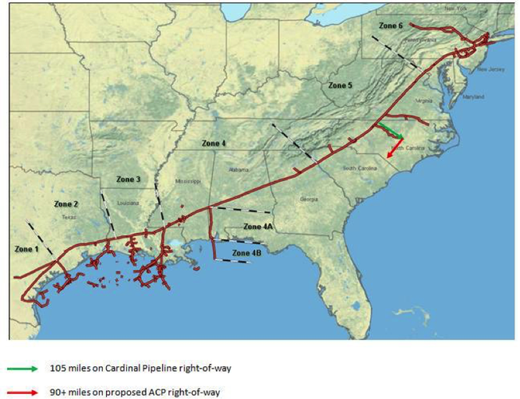
Connections to the Transcontinental Pipeline corridor serve the same customers in North Carolina as the ACP, saving billions.
With demand for natural gas slowing, rushing to build the ACP risks making a costly mistake
Dominion and Duke have been scaling back the number of gas-fired units that require service from the ACP and pushing back the expected dates for initial operation. Just this year, the two companies cut in half the number of large gas-fired power plants needed in the next 15 years. The first unit is not needed until 2025, in Virginia. There is no need to rush through the regulatory process. We have time to do a thorough evaluation of the need, costs and impacts of new pipeline projects.
Growth in U.S. natural gas use has slowed markedly, further undermining the ACP’s need argument and the artificial sense of urgency to gain regulatory approvals. An industry analyst says, “With domestic demand gains slowing across power burn, residential, commercial, and industrial, the North American gas market must find new levers to pull. It is likely that the biggest demand lever for the U.S. gas market over the next five years and beyond will be LNG exports.” This statement indicates that the rapid growth in natural gas use is not shaping up as policymakers were led to believe. The industry is looking to greater LNG exports as a way to increase natural gas prices and rescue Wall Street’s failing investments in natural gas developers.
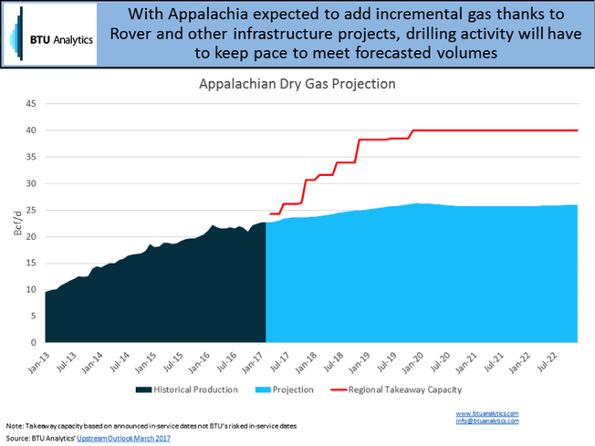
As the red line of the chart shows, pipeline capacity in the Appalachian Basin is growing much faster than the supply of natural gas.
The Appalachian Basin is not producing enough gas to fill all of the pipelines that are currently in front of FERC for approval. The production of natural gas would have to increase by 50 percent in the Marcellus/Utica shale plays to fill the pipelines currently proposed over the next several years. Rather than reducing the number of pipelines built, the industry is suggesting that we need to drill for more gas.
Australia tried to use its ample reserves of natural gas to increase domestic use and LNG exports. They converted many factories to natural gas in hopes of creating more jobs. Instead of greater prosperity, domestic gas prices rose 3-4 times in 10 years, factories closed or converted back to coal, and utility bills skyrocketed.
Learning from others’ mistakes: Florida’s example
The ACP is not the only pipeline project to overestimate demand. Further south, Sabal Trail, the most recent pipeline to go into operation, is running at 25% capacity, all of it taken from existing pipelines. This new pipeline, in rapidly growing Florida, was promoted as being absolutely necessary to meet growth in natural gas demand by its utility holding company owners, NextEra and Duke Energy. Yet, total natural gas usage in Florida is down 4% over last year, undercut by cheaper renewables.
If Virginia’s families and businesses lose, who wins?
It can be puzzling to understand why utility holding companies want to build a pipeline if it isn’t needed. It seems unlikely that an unregulated, private corporation would invest billions of dollars in a project the market doesn’t support. The answer has to do with the way the utility subsidiaries are compensated. Our utilities get paid more when they build more. Today, there is little reason to build new power plants, because demand for electricity is no longer growing nationwide, even though there is growth in our economy and population. Demand for electricity in Virginia is growing only because of new data centers and Dominion’s studies show that growth from that source will taper off by 2023.
FERC offers a 50% higher return for gas pipelines than for interstate transmission lines. The holding company executives are making what they see as a prudent decision to chase this extra money, while revenues from their utility subsidiaries are flat, and shift the risk and higher costs to the utility ratepayers.
A choice that is good for the shareholders but bad for the ratepayers is not one that we should encourage. A company cannot be successful in the long run setting the interests of its owners against the interests of its customers. If Dominion builds the pipeline and successfully convinces the SCC to pass on the full costs of the 20-year agreements to the ratepayers, customers will pay billions more for no benefit. This would give them a reason to do less business with Dominion in the long run (using energy efficiency and self-generation with solar to reduce their usage). The higher costs due to the pipeline would create a less healthy state economy and a less healthy utility.
We need to create different approaches where everyone can benefit. To do that, we must reset the role of our utilities and pay them differently so they can prosper when they serve us better, as other states are doing.
Given that the economic benefits we have been promised will not materialize, we should ask the state and federal regulators to fully analyze the need for this project and make a thorough assessment of its impacts. We have the time. The process could take two more years and still not affect the operation of any of the new power plants in Virginia or North Carolina that were used to justify the pipeline.

Thomas Hadwin
Waynesboro, VA


Thomas Hadwin worked for electric and gas utilities in Michigan and New York. He led a department which was responsible for the site selection and approval of multi-billion dollar projects working with state and federal agencies, as well as assuring that all company facilities complied with existing environmental regulations. He founded a computer and telecommunications business about which the Wall Street Journal wrote an article describing its innovative business model. As a “healer of businesses” he helped ailing companies throughout the U.S. get back on their feet. He is currently working to help establish a 21st century energy system for Virginia.

