IN THE MATTER

Of the Buckingham Compressor Station

Supplementary Testimony of
George Thurston Sc.D.

January 4, 2019

ImPlications of Dr. FJord’s Union Hill Survey to Air Pollution Health IMpacts of the Buckingham Compressor Station
Q. What are the factors that cause a person or a population to be more at risk from air pollution exposure, such as the exposures that will be associated with the proposed Buckingham Compressor Station?
A. As discussed in my original Declaration, September 21, 2018, and in the recent treatise on air pollution health effects by Schraufnagel et al (2018) (to which I am a co-author), both extrinsic (external) and intrinsic (internal) factors determine vulnerability to adverse health effects from exposures to air pollution. The most important extrinsic population factor is the level of exposure to pollution. People of lower social and economic status often have greater exposures to air pollution because they often live in areas of greater traffic density and near point sources of pollution such as power plants and industrial facilities like the proposed natural gas combustion compressor station. Other extrinsic neighborhood factors that contribute to vulnerability include poor housing, the lack of stores to purchase healthy food (e.g., fruits and vegetables that contain antioxidants), violent crime, segregation, lack of green space, and poor access to health care. Intrinsic individual factors that increase vulnerability to air pollution include age (very young and very old), preexisting disease, pregnancy, genetic and epigenetic variation, smoking, and obesity. The concept of cumulative risk combines both the extrinsic and intrinsic factors when attempting to assess the vulnerability of an individual or a population to the ill effects of air pollution.
A.
A. Q. How do the results of Dr. Fjord’s Community Questionnaire relate to the consideration of the human health impacts of the air pollution resulting from operation of the proposed compressor station?
A. Dr. Fjord’s report indicates that a number of the above extrinsic and intrinsic factors that increase the adverse effects of air pollution are present in this population. Regarding extrinsic risk factors, as shown in the below figure, a high percentage of the studied Union Hill population live immediately around the proposed facility, most within one mile of the facility, and therefore will receive the highest pollution exposures from the facility’s operation. In addition, though not included in Dr. Fjord’s household survey, this is a neighborhood with a very high percentage of residents living in poverty, which is another extrinsic risk factor for environmental health effects. This fact is confirmed by the census information for the neighborhood’s Census tract (9301.01) which has a poverty rate of 26.6% (Virginia DEQ, 2018), which is more than double that of the State of Virginia, overall (11%).
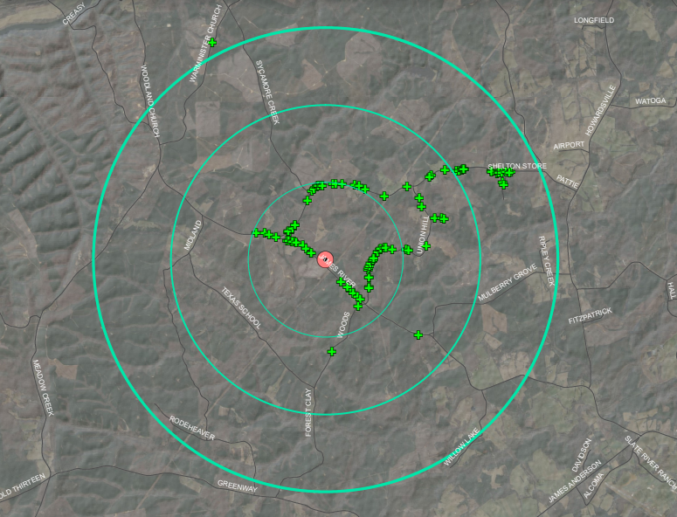
Figure 1. Location of Union Hill Residents Surveyed relative to the proposed facility (red dot). Rings are 1, 2, and 3 miles from the proposed facility location.(Source: Comments of Stephen Metts)
In addition, the population living near the proposed facility are shown by Dr. Fjord’s results to have multiple individual intrinsic risk factors. For example, as shown by Table 1 from her report, race by self-identification indicated that minorities, an especially susceptible population, make up 83.5% of residents.
Table 1. Race by self-identification of Surveyed Union Hill Residents
 | African  American | Native American and African American | White | Native  American and White | Native  American | Hispanic | Asian
Count | 124 | 27 | 33 | 9 | 3 | 3 | 1
% | 62 | 13.5 | 16.5 | 4.5 | 1.5 | 1.5 | .5

Moreover, as shown in Table 2, of Weekday residents, 32% are Children, and 25% Elderly, which are both intrinsic susceptibility risk factors for air pollution exposure.
Table 2. Age Distribution of Surveyed Union Hill Residents
Age Range | 0-6 | 7-18 | 18-21 | 22-40 | 41-65 | 65+ | Unknown | Total
Count | 28 | 36 | 5 | 36 | 43 | 50 | 2 | 200
% | 14 | 18 | 2.5 | 18 | 21.5 | 25 | 1 | 100
Importantly, for the 67 households where Dr. Fjord’s research team was able to have extensive questionnaire time, 35 responded with pre-existing medical diagnoses or 59.32% of reached households. This indicates a very high percentage of susceptible people due to their having a pre-existing health condition.
Q. Based on this information what are your Conclusions?
A. The population surrounding the proposed facility location is seen to have multiple susceptibility risk factors, and, as a result, to be especially vulnerable to exposure and susceptible to the adverse health effects of the air pollution from the proposed Buckingham Compressor Station. It is therefore concluded that this especially vulnerable population will suffer especially increased health risks associated with operation of the facility.

LITERATURE CITED
Fjord, Lakshmi. Union Hill Household Study. 01-02-2019.
Schraufnagel DE, Balmes JR, Cowl CT, De Matteis S, Jung SH, Mortimer K, Perez-Padilla R, Rice MB, Riojas-Rodriguez H, Sood A, Thurston GD, To T, Vanker A, Wuebbles DJ. Air Pollution and Noncommunicable Diseases: A Review by the Forum of International Respiratory Societies' Environmental Committee, Part 1: The Damaging Effects of Air Pollution. Chest. 2018 Nov 9.

Virginia DEQ. (2018). Appendix U .Racial, Ethnic, And Poverty Statistics For Census Tracts Within 1 Mile Of The Atlantic Coast Pipeline And Supply Header Project. https://www.google.com/url?q=https://www.deq.virginia.gov/Portals/0/DEQ/Air/BuckinghamCompressorStation/PUBLIC_COMMENT_DOC_FEIS_Volume-III-part-2%2520-Appendix_U-statistics_for_census_tracts.pdf&sa=D&ust=1546658697684000&usg=AFQjCNHNCnX8cWVFhqkEwIFWtpyPBvfV6g

