
YOUR COMMUNITY AIR QUALITY ASSESSMENT RESULTS: Particulate Matter (PM2.5) and Volatile Organic Compounds (VOCs)

Prepared by the Environmental Health Project
470 James St, Suite 007. New Haven, CT 06513

CONTENTS
Contents……………………………………………………………………...……2
Introduction………………………………………………………………………3
Outdoor PM2.5 Community Results………………………………….4-5
VOC Community Results……………………………………………………6-9
Recommendations for Home Air Quality…………………………..10

Dear Buckingham and Wingina residents,
Thank you for your participation in the Environmental Health Monitoring Project. We are providing you with an analysis of the data collected from Specks used in your community in June-July of 2018. With information from these monitors, we can provide an estimate of baseline outdoor air quality in your community for this time period. If you have any questions please do not hesitate to contact us at: sjoginpally@environmentalhealthproject.org or clewis@environmentalhealthproject.org.

What is in this Report? This report gives a summary of results from 2018 community air monitoring. It shows how these results compare to other results that EHP has reviewed in New York, Ohio, California and Pennsylvania. Pages 4-5 show the community results for PM2.5 monitoring. You will also find results from Volatile Organic Compounds (VOCs) sampling on pages 6-9. VOC samples, at four locations, were collected near the compressor site for a 24-hour period. Samples were collected on July 16th and July 20th 2018.

OUTDOOR PM_{2.5} RESULTS:
The figures on page 4 (1A-E) show the range of results of PM_{2.5} monitoring for five components measured (peaks per day, duration of peaks, time between peaks, baseline air quality, and accumulated particle matter) using Speck monitor data. The results are shown in relation to the entire Speck monitor data reviewed so far at EHP.
We monitored for PM2.5 at eight residences/locations in your area. One monitor malfunctioned and two came back with little or no data so results from 5 outdoor Speck monitors are provided here. The results from all five outdoor monitors show that when peaks occur, they are of short duration – below the average of 24 minutes. Other results are split, with monitors showing higher and lower levels than average values.
It is normal for peaks to occur occasionally, and there are many possible sources of these peaks. The use of wood stoves, outdoor barbeque and heating with wood in winter can be significant sources of these peaks (see recommendations for home air quality on page 10 for more information). The wind direction and wind speed from the natural gas compressor site or another nearby source could also affect these results.
In the bar charts below, each orange dot represents the average results for outdoor air levels at one home. The blue bar marks the average (median) of all results compiled by EHP.
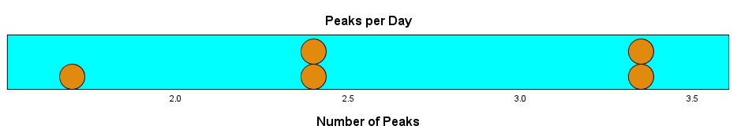

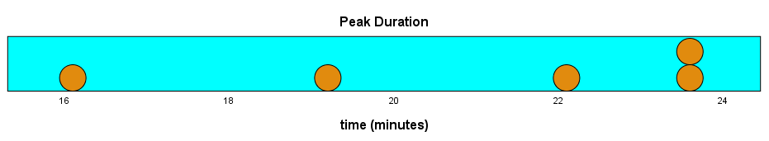
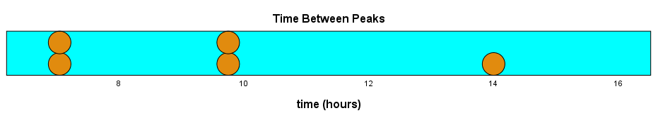

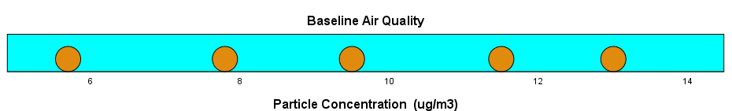

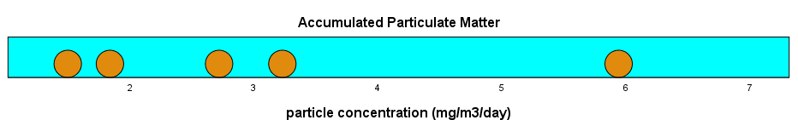

Figure 1A. Peaks per day: This dot plot shows the average number of large-scale changes (peaks) in air quality per day recorded by each Speck over a 32-day period. These results range from about 1.7 to 3.4 peaks per day.

Figure 1B. Duration of peaks: This dot plot shows the average length of time peaks lasted. These results show each peak lasted from about 16 - 24 minutes with all results below average.

Figure 1C. Time between peaks: This dot plot shows the average length of time between peaks. The fewer the number of peaks, the greater the time period between peaks. These results range from about 7 -14 hours.

Figure 1D. Baseline air quality:
This dot plot shows the level of particles generally found outside when peaks are not occurring. These results show two locations being lower and three occurring at higher than average baseline outdoor air quality.

Figure 1E. Accumulated particle matter: This dot plot shows the total sum of particle counts over the 32-day period for each outdoor Speck. These results show a range for 5 locations; one above and all the others below the average level of accumulated PM2.5.

The chart below shows the results from the 5 outdoor Speck monitors placed in the community for 32 days. There were times when peaks in PM2.5 exposure occurred simultaneously and times when exposures were different. The difference is likely due to the location of Specks, wind direction and the location of the source of PM2.5. If a source of air pollution is nearby, these conditions could cause increased exposure for residents. Chemicals from the source may combine with the particulate matter and travel to the deep regions of the lungs to cause respiratory problems or gain access to other parts of the body through blood-gas exchange. Indoor Speck results have been provided to individual residents.
Outdoor PM2.5 results from 5 locations from June 4 – July 6, 2018
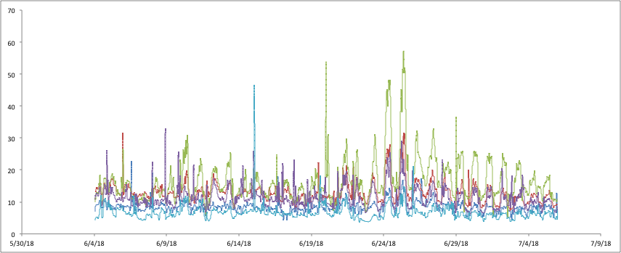

Monitoring for Volatile Organic Compounds (VOCs)
Using four summa canisters, you collected 24-hour air samples and tested for 69 chemicals. The lab detected 3 chemicals in sample 1 and 4 in sample 2 on 7/16 and 1 in sample 3 and 2 in sample 4 on 7/20. Although exposure levels are below the threshold, we believe continued or longer duration of exposure to low levels may also significantly impact health. Table 1 shows which chemicals were found, potential health effect parameters and a color-coded analysis about the safety of this particular exposure. For each chemical identified there is a threshold to consider action. This is the level at which residents should be concerned about harmful exposure to a chemical. In this sample all chemicals were found at levels below what we think would cause immediate health effects. We still recommend taking action to limit your exposures (see recommendations at the end of the report) and providing this information to your Physician or primary health care provider. You also sampled for hydrogen sulfide and formaldehyde using separate badges on 7/16 and 7/20. No hydrogen sulfide was detected however formaldehyde was detected in two samples on 7/16 and in one sample on 7/20.

RESULTS KEY
No action recommended due to no current health concern

Action recommended due to potential health concern

Immediate action strongly recommended due to significant and/or immediate health concern

Use the results key to quickly review the VOC results.
Use this key as your at-a-glance to quickly find items with an orange button that have the potential to impact your health or items with a red button that pose a significant and possible immediate concern for health.

Table1. Outdoor VOC readings in the community:
Source: http://www.atsdr.cdc.gov/mrls/mrllist.asp
Sample 1 collected on July 16th/2018
Air Test Parameter | Threshold Source | Threshold to Consider Action* | Outdoor Air Test Result | Potential Health Effects of Parameter | Analysis
Acetone | ATSDR | 26 ppm | 6.0 ppbV  (0.006 ppm) | Neurological effects
Chloromethane | OSHA | 50 ppm  (1.66 ppm)* | 0.53 ppbV  (0.00053 ppm) | Neurological and cardiovascular effects. May damage liver and kidneys.
2-Butanone | OSHA | 200 ppm  (6.66 ppm) | 0.67 ppbv  (0.00067 ppm) | Eyes, Skin, Respiratory system and Central Nervous System
Formaldehyde | ATSDR | 0.003 ppm^ | 0.0058 ppm | Known human carcinogen
^Urban area threshold levels are typically higher, between 0.011 – 0.020 ppm.

Sample 2 collected on July 16th/2018
Air Test Parameter | Threshold Source | Threshold to Consider Action* | Outdoor Air Test Result | Potential Health Effects of Parameter | Analysis
Acetone | ATSDR | 26 ppm | 8.0 ppbV  (0.008 ppm) | Neurological effects
Chloromethane | OSHA | 50 ppm  (1.66 ppm)* | 0.56 ppbV  (0.00056 ppm) | Neurological and cardiovascular effects. May damage liver and kidneys.
2-Propanol | OSHA | 400 ppm  (13.3 ppm)* | 2.4 ppbv  (0.0024 ppm) | Neurological and cardiovascular effects.
2-Butanone | OSHA | 200 ppm  (6.66 ppm) | 0.78 ppbv  (0.00078 ppm) | Eyes, Skin, Respiratory system and Central Nervous System
Formaldehyde | ATSDR | 0.003 ppm | 0.0079 | Known human carcinogen
^Urban area threshold levels are typically higher, between 0.011 – 0.020 ppm.

Sample 3 collected on July 20th/2018
Air Test Parameter | Threshold Source | Threshold to Consider Action* | Outdoor Air Test Result | Potential Health Effects of Parameter | Analysis
Acetone | ATSDR | 26 ppm | 4.4 ppbV  (0.0044 ppm) | Neurological effects

Sample 4 collected on July 20th/2018
Air Test Parameter | Threshold Source | Threshold to Consider Action* | Outdoor Air Test Result | Potential Health Effects of Parameter | Analysis
Acetone | ATSDR | 26 ppm | 5.8 ppbV  (0.0058 ppm) | Neurological effects
Chloromethane | OSHA | 50 ppm  (1.66 ppm)* | 0.52 ppbV  (0.00052 ppm) | Neurological and cardiovascular effects. May damage liver and kidneys.
Formaldehyde | ATSDR | 0.003 ppm | 0.0041 ppm | Known human carcinogen
* Exposure limits from OSHA are for an 8-hr workday schedule. EHP computes lower thresholds for residential areas for 24 hours of exposure, and also includes a calculation for vulnerable individuals including children and the elderly and others who may be more susceptible to these contaminants. These thresholds are found in parentheses, see Chloromethane (1.66ppm) for example. ^Urban area threshold levels are typically higher, between 0.011 – 0.020 ppm.

Recommendations for the Home Environment
The periods of exposure at your home could be related to a number of nearby sources or activities. Try to identify sources of emissions, both inside and outside your house. These may include:
- Non-Vented Kitchens and Bathrooms – Improved ventilation can decrease moisture in home that can result in condensation and mold, decreases odors, and improve air quality.
- Heating systems – The heating system in your home may be decreasing the air quality if your heating source is oil, kerosene, wood, propane, or coal. It may be adding to the level of fine particulate matter in your home and the air you breathe.
- Homes built before 1978 may have products that contain lead.
- Homes built before 1930, which have not been renovated, may have asbestos that if disturbed could cause illness.
- New furniture, carpet, vinyl flooring or refinished furniture may be high in formaldehyde, a chemical that is a probable carcinogen.
- Winterizing your home may increase the efficiency of your heating or cooling system, but it also has the potential to increase radon levels and increase the level of indoor air contaminants.
- Carbon monoxide detectors are recommended in any homes with gas, oil or wood fuel-burning appliances in case of accidental carbon monoxide poisoning.
- If radon has been detected in your home, it poses an increased risk for lung cancer, especially among non-smokers.
- The use of pesticides or herbicides (bug or weed killers, flea or tick sprays, collars, powders, or shampoos) in your home, lawn, garden, or on your pets may pose a health concern.
- Pets in the home – Pets and other animals can increase the amount of dust and dander in a home and be a trigger for asthma.

Please see EHP’s Recommendations for reducing exposures to air particles in your home at:
http://www.environmentalhealthproject.org/health-issues/air

If you have any questions, please do not hesitate to contact us via email or phone call.

Thank you again for working with EHP
Sujit Joginpally MD, MBA
sjoginpally@environmentalhealthproject.org
Ph.: 201-660-5447

Celia Lewis PhD
Research and Communications
clewis@environmentalhealthproject.org

Acronyms
US EPA United State Department of Environmental Protection
ATSDR Agency for Toxic Substances and Disease Registry of the Centers for Disease Control and Prevention
NIOSH National Institute for Occupational Safety and Health
OSHA Occupational Safety and Health Administration
PEL Permissible exposure limits
REL Recommended exposure limit
µg/m³ Micrograms per cubic meter air quality measurement
mg/m³ Micrograms per cubic meter air quality measurement
ppm parts per million
ppb parts per billion

